 



Database Programming with SQL 15-1: Creating Views

Practice Activities

# Objectives

* List three uses for views from the standpoint of a database administrator
* Explain, from a business perspective, why it is important to be able to create and use logical subsets of data derived from one or more tables
* Create a view with and without column aliases in the subquery using a single base table
* Create a complex view that contains group functions to display values from two tables
* Retrieve data from a view

# Vocabulary

Identify the vocabulary word for each definition below.

|  |  |
| --- | --- |
| **VIEW** | A subset of data from one or more tables that is generated from a query and stored as a virtual table |
| **VIEW_NAME** | Name of view |
| **FORCE** | Creates a view regardless of whether or not the base tables exist |
| **SIMPLE VIEW** | Derives data from a table, no functions or groups, performs DML operations through the view |
| **NOFORCE** | Creates the view only if the base table exists |
| **CREATE VIEW statement** | Statement used to create a new view |
| **Alias** | Specifies a name for each expression selected by the view’s query |
| **subquery** | A complete SELECT statement |
| **Complex View** | Derives data from more than one table, contains functions or groups of data, and does not always allow DML operations through the view |
| **REPLACE** | Re-creates the view if it already exists |

# Try It / Solve It

1. What are three uses for a view from a DBA’s perspective?

**Ограничение доступа и отображение выборочных столбцов**

**Снижение сложности запросов из других внутренних систем. Таким образом, предоставляя способ просмотра одних и тех же данных по-разному**

**Разрешить коду приложения полагаться на представления и разрешить позже изменить внутреннюю реализацию таблиц**

1. Create a simple view called view_d_songs that contains the ID, title, and artist from the DJs on Demand table for each “New Age” type code. In the subquery, use the alias “Song Title” for the title column.

SELECT d_songs.id, d_songs.title "Song Title", d_songs.artist

from d_songs INNER JOIN d_types ON d_songs.type_code = d_types.code

where d_types.description = 'New Age';

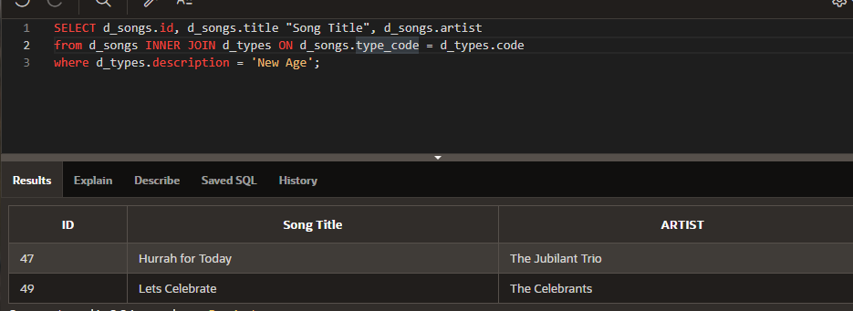

CREATE VIEW view_d_songs AS

SELECT d_songs.id, d_songs.title "Song Title", d_songs.artist

from d_songs INNER JOIN d_types ON d_songs.type_code = d_types.code

where d_types.description = 'New Age';

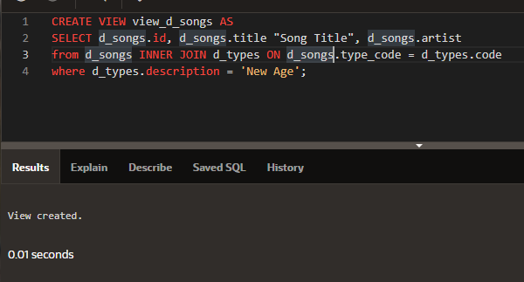

CREATE OR REPLACE VIEW view_d_songs AS

SELECT d_songs.id, d_songs.title "Song Title", d_songs.artist

from d_songs INNER JOIN d_types ON d_songs.type_code = d_types.code

where d_types.description = 'New Age';

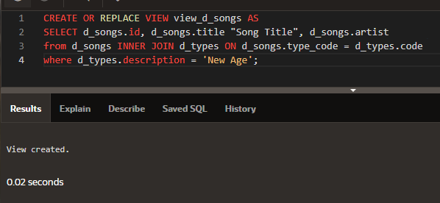

SELECT * FROM view_d_songs ;

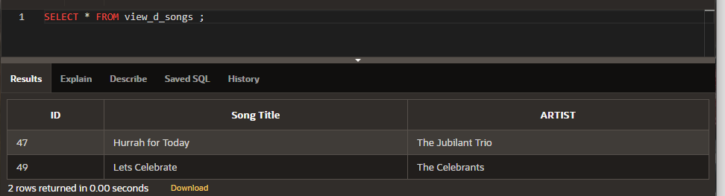

1. SELECT *

FROM view_d_songs. What was returned?

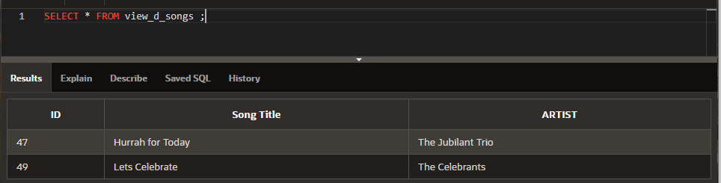

1. REPLACE view_d_songs. Add type_code to the column list. Use aliases for all columns.

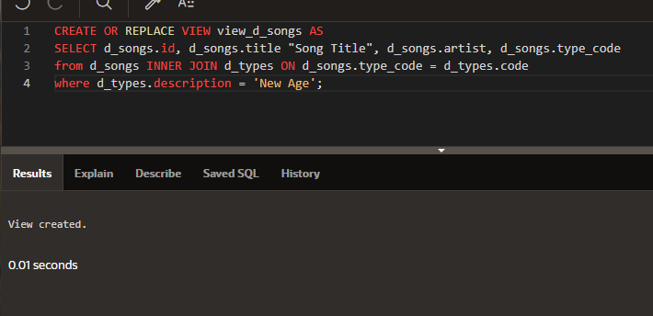

1. Jason Tsang, the disk jockey for DJs on Demand, needs a list of the past events and those planned for the coming months so he can make arrangements for each event’s equipment setup. As the company manager, you do not want him to have access to the price that clients paid for their events. Create a view for Jason to use that displays the name of the event, the event date, and the theme description. Use aliases for each column name.

CREATE OR REPLACE VIEW view_d_events_pkgs AS

SELECT evt.name "Name of Event", TO_CHAR(evt.event_date, 'dd-Month-yyyy') "Event date", thm.description "Theme description"

FROM d_events evt INNER JOIN d_themes thm ON evt.theme_code = thm.code

WHERE evt.event_date <= ADD_MONTHS(SYSDATE,1);

SELECT * FROM view_d_events_pkgs ;

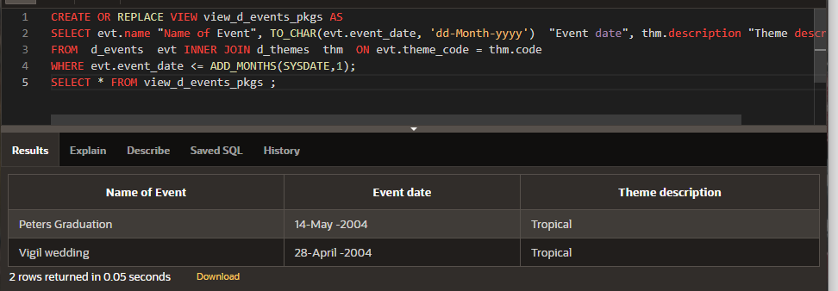

1. It is company policy that only upper-level management be allowed access to individual employee salaries. The department managers, however, need to know the minimum, maximum, and average salaries, grouped by department. Use the Oracle database to prepare a view that displays the needed information for department managers.

CREATE OR REPLACE VIEW view_min_max_avg_dpt_salary ("Department Id", "Department Name", "Max Salary", "Min Salary", "Average Salary") AS

SELECT dpt.department_id, dpt.department_name, MAX(NVL(emp.salary,0)), MIN(NVL(emp.salary,0)), ROUND(AVG(NVL(emp.salary,0)),2)

FROM departments dpt LEFT OUTER JOIN employees emp ON dpt.department_id = emp.department_id

GROUP BY (dpt.department_id, dpt.department_name);

SELECT * FROM view_min_max_avg_dpt_salary;

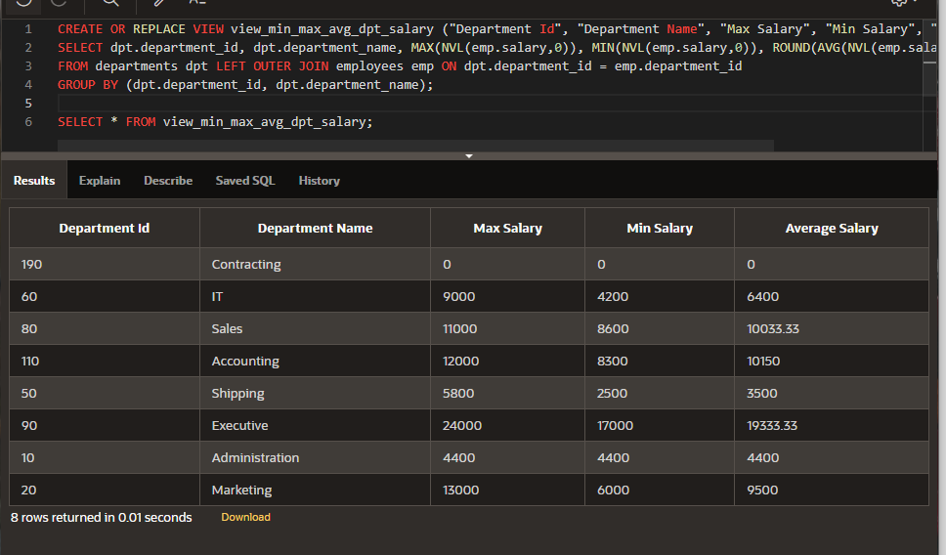

Copyright © 2020, Oracle and/or its affiliates. All rights reserved. Oracle and Java are registered trademarks of Oracle and/or its affiliates. Other names may be trademarks of their respective owners.